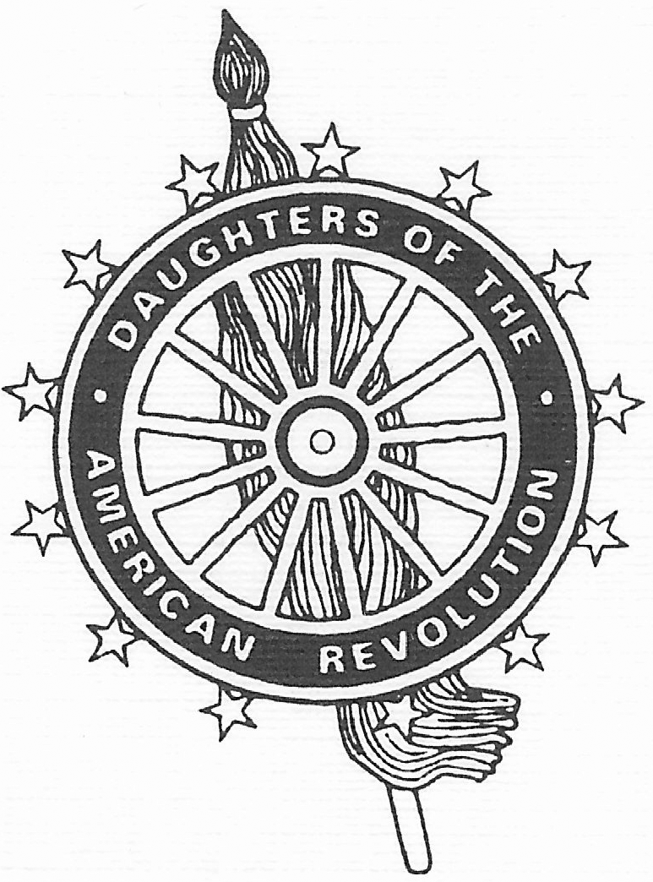 | The Hawai’i State Organization  Daughters of the American Revolution  and  The Hawai’i State Society  Sons of the American Revolution
Invite you to attend their annual joint luncheon
Saturday, March 7, 2020
West Hawaii Civic Center Conference Room A
74-5044 Ane Keohokalole Hwy, Kailua-Kona, HI 96740

Keynote Speaker – Mr. Moses Goods
Theatre Artist
Luncheon Buffet – Local Favorites
Vegetarian Options Available

Luncheon Registration: 11:30 a.m. Luncheon & Program: 12:00 p.m.
Cost: $35.00 per person
Guests are welcome
Aloha Attire Suggested

_________________Please Detach Form and Return It with Payment _____________
DAR Conference & DAR/SAR Luncheon Reservation Form

Name: ________________________________ DAR: _____ SAR: _____ Guest: _____

Choose A or B, plus additional donations if applicable:
_____ A. DAR Conference ONLY. I enclose my payment of $10.00
_____ B. DAR/SAR Luncheon (with or without morning session): I enclose my payment of $35.00
_____ General Donation to State Project (Please specify amount)
_____ Additional General Donation to State Treasurer (Please specify amount)

DAR Members & Guests: | SAR Members & Guests:
Please make checks payable to: Hawai’i State Organization, NSDAR and mail to:  Margaret Russo. Treasurer  P.O. Box 428  Volcano, HI 96785-0428 | Please make checks payable to Hawai’i Society SAR and mail to:  Elbridge W. Smith, Treasurer  745 Fort Street, Suite 311  Honolulu, HI 96813

All Attendees: To help us keep track of registrations, please send an email to Margaret Russo at ret.russo@gmail.com with your name(s), the amount of your check, and the date the check was mailed. Please also indicate special dietary needs in your email.
**Reservations and payment must be received by Friday, February 7, 2020. Mahalo!

