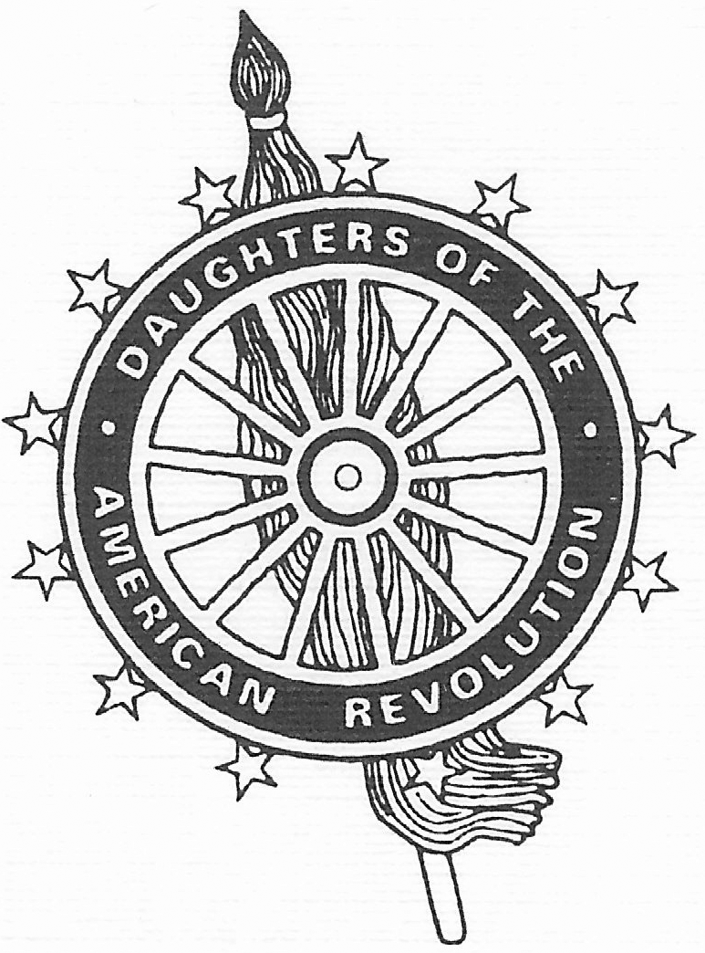 | The 97th State Conference  of the  Hawai’i State Organization
National Society Daughters of the American Revolution

Is hereby called by

Jane Mann
State Regent

To convene
Saturday, March 7, 2020
9:00 a.m.

West Hawaii Civic Center Council Chambers
74-5044 Ane Keohokalole Hwy, Kailua-Kona, HI 96740
Aloha Attire Suggested
8:30 – 8:55 a.m.  9:00 a.m.  12:00 p.m. | Registration  Conference  Reports of the State Officers, Chapter Regents and State Chairmen  *Coffee, water & pastries provided  DAR/SAR Joint Luncheon | “Rise and Shine for America"  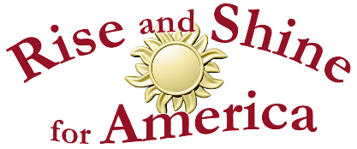
Registration: Please use the Conference & DAR/SAR Luncheon Reservation form (attached to the luncheon invitation) to register. Payment must be received by Margaret Russo, Hawai’i State Treasurer no later than Friday, February 7, 2020.
DAR State Conference only: $10.00
DAR State Conference & Luncheon: $35.00
DAR/SAR Luncheon only: $35.00

