Nevada State Society
Sons of the American Revolution

66th Annual State Conference

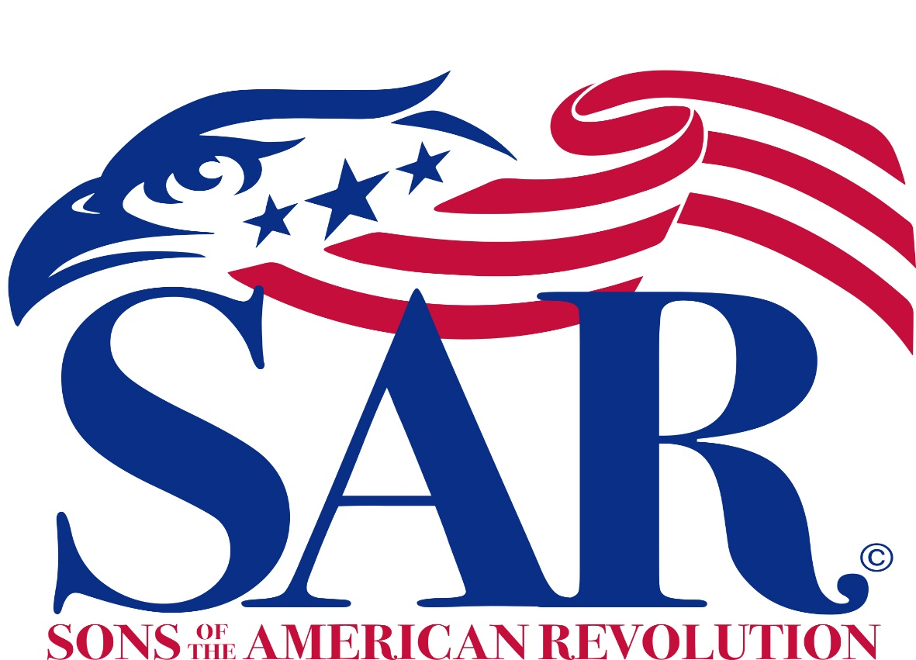

J. Michael Fitzpatrick

State President

April 10th, 2021
Reno, Nevada

Nevada State Society Annual Meeting Agenda

- Call to order and welcome
  - President
- Invocation
Chaplain Rev. Dr. Joseph de Beauchamp
- Pledge of Allegiance to the Flag of the United States of America
- SAR Pledge, TBD
- Introduction of Guests
  - Secretary
- Remarks
  - Greetings from others
- Approval of Minutes from the 2018 Nevada State Conference
- Officer and Committee reports
  - President, J. Michael Fitzpatrick
  - Secretary, Stephen Schroder
  - Treasurer, Al Conant (call for approval of financial report)
  - Registrar, Charles B. Smith V
  - Chaplain, Dr. Joseph de Beauchamp
  - Historian, David Hess
  - Committees, Scholarships, ??, Chairmen
  - Battle Born Patriot Chapter, David Hess
  - Signers Chapter, Charles Smith & Tim Hagan

- Old Business
- New Business
  - Report of the Nominating Committee and election of State Officers, Chairmen or Secretary
  - Report of the Nominating Committee and election of Paul Jones Memorial Educational Fund Trustee Officers
- Awards Presentations, Award Committee Chairman & President
- Scholarship Awards, one NVSSAR, three Signers Chapter
- Introduction of New Officers
- Oath of Office:
  - Vice President General, Western Region, James Fosdyck
- Presentation of State President’s Neck Ribbon
  - By Outgoing President
  - Turnover meeting to newly elected President
- Presentation of Past State President’s Pin
  - By Incoming President
- Incoming President’s Remarks
- Remarks for the Good of the Order
- SAR Closing, Tim Hagan
- Adjournment

2021 Scholarship Award Winners

State Society – Paul Jones Memorial Education Scholarship: Dana Surwill

Signers Chapter – John Harney, Jr. Educational Scholarship Fund: Bethany Blakely, Nathaniel Ohlinger, and 1 unknown recipient

Ladies Auxiliary Scholarship: None

2021 Slate of Officers—Nevada State Society

Office | Representative
President | Charles B. Smith V
President Emeritus | J. Michael Fitzpatrick
Vice President North | David Hess
Vice President South | Timothy Hagen
Secretary | Stephen Schroder
Treasurer | Albert Conant
Registrar | VOTE
Chaplain | Rev. Dr. Joseph deBeauchamp
Historian | David Hess
Webmaster | Paul Bell
State Surgeon | Dr. Donald McGee
Chancellor | Dr. Daniel L. Orr II, Esq
DAR Liaison North | Roger Linscott
DAR Liaison South | Albert Conant
CAR Liaison | Marcus Green
Boy Scout Chairman | VOTE
Commander of the Color Guard | VOTE
Trustee | Charles Smith
Alternate Trustee | VOTE

2021 Slate of Board of Trustees
Paul Jones Memorial Educational Fund

OFFICE | REPRESENTATIVE
President: | VOTE
Vice President: | Ben Allen
Secretary/Treasurer: | VOTE
Trustee(s): | VOTE

Minutes of
The Nevada Society 65th Annual State Conference
April 4, 2020

The 65th Annual State Conference was scheduled to take place at the Atlantis Casino Resort in Reno Nevada on the 4th and 5th of April 2020. Despite many months of planning for this important event by the hard working Battle Born Patriot Chapter, the Corona Virus upset these plans and the Society was forced to cancel, or at the very least postpone the conference. Nevertheless, the needs of the Society demanded that at the very least Elections must be held and various business activities needed to be addressed. Therefore it was mutually decided to Teleconference on the 4th of April 2020 at 10:00 AM. These are the minutes of the Teleconference Business Meeting.
Nevada Society Members On-Line
Donald Hotchkiss, Al Conant, David Hess, Roger Linscott, Stephen Schroder,
James McLane, Paul Hicks, Michael Fitzpatrick, Charles Smith V, David Smith, Bob Till
Jim Farmer, Paul Bell, Jonathan Dickey, Gary Parriott, Brian Worcester, Bill Burton
David Barnard, Richard Dalton, Charles “Chip” MacLeod, Robert Stoecklin
Other Members On-Line
Vice President General Western District James C. Fosdyck
Guests On-Line
Un Hui Yi Fosdyck
Patricia?

Opening Remarks President Donald L Hotchkiss Jr.
Welcome to all, despite difficult times we are happy to be able to use technology to enable us to conduct this important task.

- President Hotchkiss opened the meeting with a Prayer, and led the On-Line Attendees in the Pledge of Allegiance and then the SAR Opening Pledge.

- President Hotchkiss next requested a motion to accept the minutes of the 64th Annual State Conference, which was held in Tonopah Nevada on April 13, 2019 (Attachment 1). President Emeritus Roger Linscott made the motion, Past Vice President General Western District Brian Worcester seconded and the motion passed.

- President Hotchkiss next requested a motion to accept the Treasurers Report (Attachment 2), (which had been emailed to the membership along with other documents to be addressed later on at this meeting).
President Emeritus Paul Hicks made the motion, Past Vice President General Western District Brian Worcester seconded and the motion passed.

- Approval of the Paul Jones Memorial Scholarship Fund Bylaws Changes was to be addressed next. These Bylaws with changes are attached below (Attachment 3). President Hotchkiss asked for a motion to accept the changes as proposed. Past Vice President General Western District Brian Worcester made the motion and President Emeritus Paul Hicks seconded, it went to a vote and the motion was passed.

- Awards and Recognition was the next item of business. President Hotchkiss announced the following awards and certificates:
Award | Recipient
Past President Pin | Donald L. Hotchkiss, Jr.
State Meritorious Service Medal | Donald L. Hotchkiss, Jr.
Patriot Medal | Roger Linscott
State Distinguished Service | Charles B. Smith, V.
State Meritorious Service Medal | Albert Conant
Bronze CAR Medal of Appreciation | Jackson Bellard – CAR NV State President
Silver Good Citizenship Medal | David Hess
Certificate of Appreciation – Co-Chairman of State Meeting 2020 | Michael Fitzpatrick  Jonathan Dickey

- President Hotchkiss asked for Chapter Reports:
  - Battle Born Patriots President David Hess had submitted his report via email (Attachment 4), He added thanks to everyone in Battle Born for their outstanding work in preparation for the Annual Conference despite the situation. President Hotchkiss also lauded their organization as an example of excellence.

- Signers Chapter President Charles Smith also submitted his report via email (Attachment 5). He noted that his chapter has learned much from the Battle Born Patriots, and have adopted some of their practices. Signer now have formal bi-monthly meetings and have adopted “Compatriot’s Muster” for the in between months. These have worked good to build rapport and camaraderie in his chapter. Also as State Registrar, he recognized Battle Born’s outstanding record of reaching out to past members and reinstating them into the active roles.

- The next order of business was the election of the slate of officers. President Hotchkiss called for nominations from the floor. Hearing none, he proceeded to ask for a vote to accept the slate of uncontested officers proposed (Attachment 6). (Note: The original slate distributed for consideration had two positions requiring a separate vote. The Color Guard Commander Position had two candidates, Robert Stoecklin and Paul Hicks, and the Secretary position had Paul Bell and Stephen Schroder. Prior to the meeting Paul Hicks withdrew his bid to be the Color Guard Commander, leaving the Secretary Position in question).

The vote was held and the uncontested officers were unanimously elected.

- Next in preparation for the vote on the remaining Secretary position, President Hotchkiss asked Paul Bell and Stephen Schroeder to each give a short introduction to the On-Line attendees. Following this introduction, while discussing the upcoming vote, Candidate Paul Bell chose to withdraw his candidacy, making Stephen Schroder our Secretary. Congratulations came from everyone.

- Signers Chapter President Charles Smith pointed out that we also needed to replace President Emeritus Rev Anthony Perry as the Jones Scholarship Fund Trustee. Treasurer Al Conant made a motion to nominate Stephen Schroder to fill this position, Signers Chapter President Charles Smith seconded the motion and the attendees made this change official.

- Installation of Officers, President Hotchkiss asked Vice President General Western District James C. Fosdyck to administer the oath of office. After swearing in the new officers, the meeting was turned over to our new President Michael Fitzpatrick.

- The final order of business was the drawing for George Washington’s Original Formula Mount Vernon Distilled Whiskey. The winner this year was Paul Hicks

- President Michael Fitzpatrick thanked everyone involved for their superb effort preparing the original conference plans, and hinted at the possibility of holding an actual meeting in the near future.

- Past Vice President General Western District Brian Worcester led the on-line attendees in the SAR Closing, and President Fitzpatrick officially closed the meeting.

For the Secretary
Albert E. Conant
Treasurer
Nevada Society SAR

The SAR Pledge
We, the descendants of the heroes of the American Revolution, who by their sacrifices, established the United States of America, reaffirm our faith in the principles of liberty and our Constitutional Republic, and solemnly pledge ourselves to defend them against every foe.

Pledge of Allegiance to the Flag of the United States of America
by: Francis Bellamy
I pledge allegiance to the Flag of the United States of America and to the Republic for which it stands, one nation under God, indivisible, with liberty and justice for all.

The Americans’ Creed
by: William Tyler Page
I believe in the United States of America as a government of the people, by the people, for the people, whose just powers are derived from the consent of the governed, a democracy in a Republic, a sovereign nation of many sovereign States, a perfect Union, one and inseparable, established upon those principles of freedom, equality, justice and humanity for which American Patriots sacrificed their lives and fortunes. I therefore believe it is my duty to my country to love it; to support its constitution, to obey its laws, to respect its flag and to defend it against all enemies.

The Preamble to the Constitution of the United States of America
We the people of the United States, in order to form a more perfect union, establish justice, insure domestic tranquility, provide for the common defense, promote the general welfare, and secure the blessings of liberty to ourselves and our posterity, do ordain and establish this Constitution for the United States of America.

SAR Closing
Until we meet again, let us remember our obligations to our forefathers, who gave us our Constitution, the Bill of Rights, an independent Supreme Court, and a Nation of Free Men.

